DAY 19 | Majority Detector and Minority Detector using Verilog HDL

Introduction:Majority Detector and Minority Detector are combinational logic circuits whose outputs depend only on the current input values.These circuits are commonly used in voting systems, fault-tolerant circuits, decision-making systems, and digital logic applications.

1. Majority Detector: A Majority Detector produces a HIGH output when two or more inputs are HIGH

Truth Table
A | B | C | Y
0 | 0 | 0 | 0
0 | 0 | 1 | 0
0 | 1 | 0 | 0
0 | 1 | 1 | 1
1 | 0 | 0 | 0
1 | 0 | 1 | 1
1 | 1 | 0 | 1
1 | 1 | 1 | 1

Minterms: Output is HIGH for
Σm(3,5,6,7)\Sigma m(3,5,6,7)Σm(3,5,6,7)

K-Map:
A\BC | 00 | 01 | 11 | 10
0 | 0 | 0 | 1 | 0
1 | 0 | 1 | 1 | 1

Simplified Boolean Expression:
Y=AB+AC+BCY = AB + AC + BCY=AB+AC+BC
2. Minority Detector: A Minority Detector produces a HIGH output when two or more inputs are LOW.

Truth Table
A | B | C | Y
0 | 0 | 0 | 1
0 | 0 | 1 | 1
0 | 1 | 0 | 1
0 | 1 | 1 | 0
1 | 0 | 0 | 1
1 | 0 | 1 | 0
1 | 1 | 0 | 0
1 | 1 | 1 | 0

Minterms: Output is HIGH for
Σm(0,1,2,4)\Sigma m(0,1,2,4)Σm(0,1,2,4)

K-Map:
A\BC | 00 | 01 | 11 | 10
0 | 1 | 1 | 0 | 1
1 | 1 | 0 | 0 | 0

Simplified Boolean Expression

Y=A′B′+A′C′+B′C′Y = A'B' + A'C' + B'C'Y=A′B′+A′C′+B′C′
Design Implementation:
Majority Detector: The Majority Detector was implemented using Verilog HDL with the simplified Boolean expression obtained from the Karnaugh Map. The design was simulated and synthesized successfully in Xilinx Vivado.

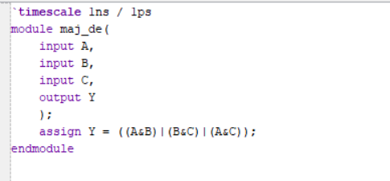

Minority Detector: The Minority Detector was implemented using Verilog HDL with the simplified Boolean expression obtained from the Karnaugh Map. The circuit was verified through simulation and synthesis in Xilinx Vivado.

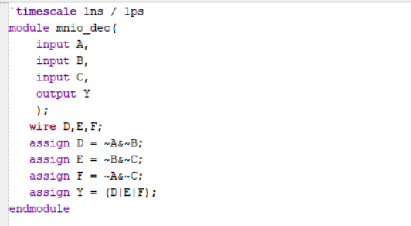

Testbench:

Majority Detector: A testbench was written to apply all eight input combinations. The output was verified with the expected truth table, and all results were correct.

Minority Detector:A separate testbench was created for the Minority Detector. All possible input combinations were tested, and the simulation results matched the expected output.

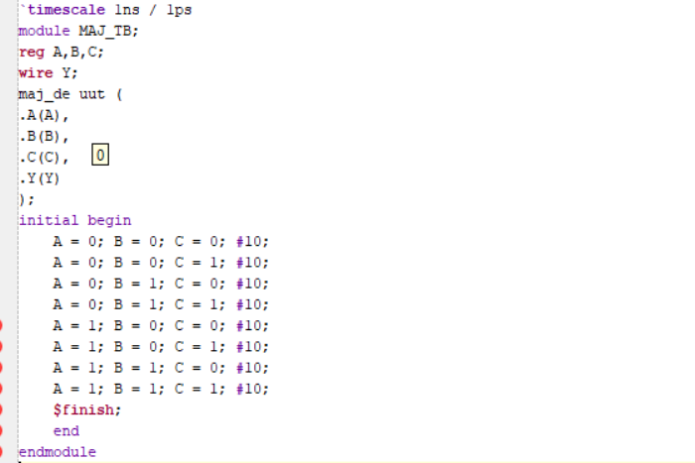

RTL Schematic:

Majority Detector: The RTL schematic generated in Xilinx Vivado shows the optimized combinational logic implementing the Majority Detector. It matches the simplified Boolean expression

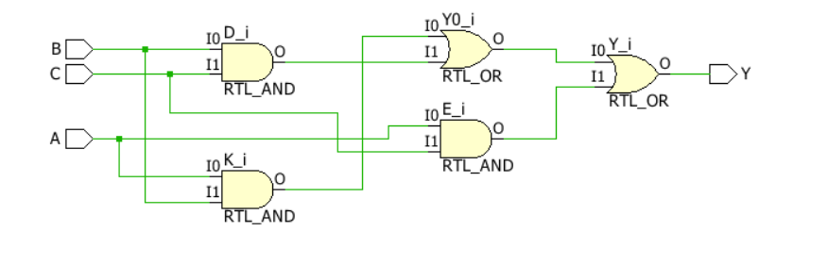.

Minority Detector: The RTL schematic generated for the Minority Detector confirms that the synthesized hardware correctly implements the simplified Boolean expression.

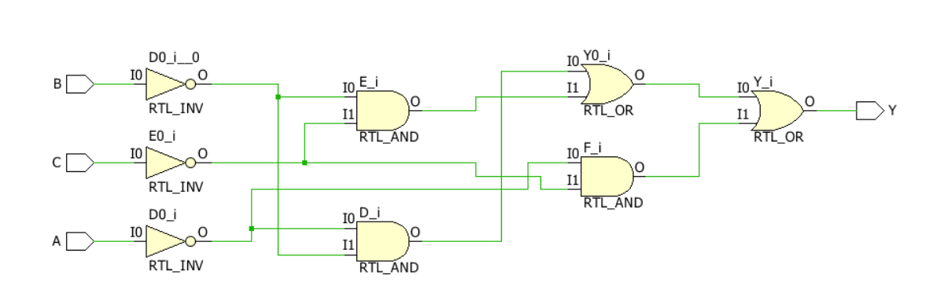

Simulation Waveform:

Majority Detector: The simulation waveform shows that the output becomes HIGH whenever two or more inputs are HIGH. The waveform matches the truth table for all input combinations.

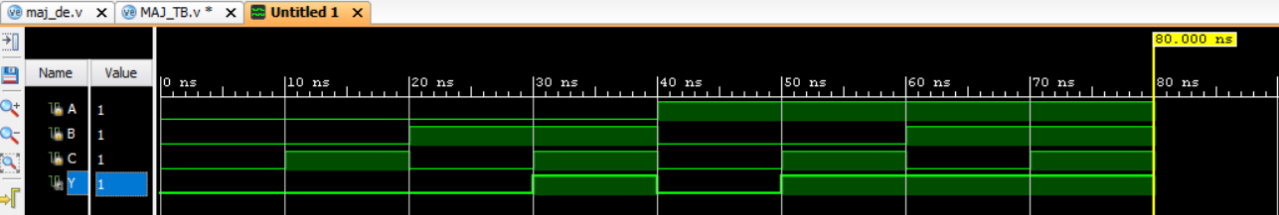

Minority Detector: The simulation waveform shows that the output becomes HIGH whenever two or more inputs are LOW. The waveform verifies the correct operation of the circuit for every input combination.

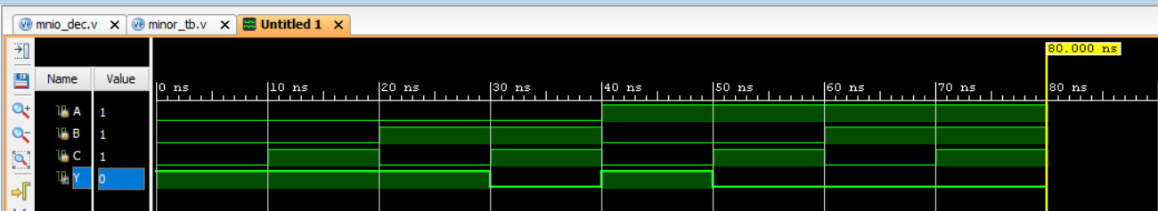

Observation:
- Designed Majority and Minority Detectors using Verilog HDL.
- Derived simplified Boolean expressions using Karnaugh Maps.
- Verified both circuits using testbenches.
- Generated RTL schematics and simulation waveforms in Xilinx Vivado.
- Successfully confirmed the functionality of both detector circuits.

#PHANEENDRA.SINGUDASU

